35

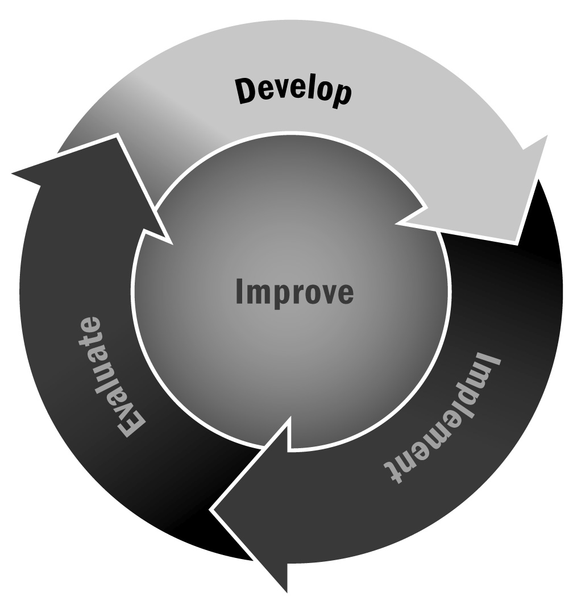
Conducting a Needs Assessment
In Chapter 2, you learned about several ways to shape your program plan around the assets and needs in your community. You can identify the needs you should address by conducting a needs assessment. In Tool 15 you learned about conducting a market analysis, and in Tool 34 you learned about going through an asset mapping process. This tool shows you how to do a needs assessment, the third component in helping you think about how to shape your program plan.
Directions: A needs assessment can be done in many different ways, depending on how much time you have, the resources you have available, and how thorough you want to be. Below are a series of ideas and activities you might include in your needs assessment. Together with your staff and advisory team, select one or several of these activities. We’ve noted what kinds of resources and how much time is required for each to help you select the most appropriate activities for you.
Surveys
Surveys are a great way to capture quantitative information about what is needed in your community (see Tool 87: Tips for Developing and Administering Surveys). Youth and family members are the most common types of people to survey. You might consider asking the following types of questions:
- What kinds of activities or programming would they like to have in an afterschool and expanded learning program (e.g., sports, academics, arts, personal and social development)?
- What kinds of activities or programming do they already access in the community (e.g., sports leagues, local Ys, scouting organizations, Boys and Girls Clubs, etc.)?
- What kind of schedule they would like to see—that is, do they want a program that is offered every day? How late do they want programs to go? For how many weeks? Throughout the school year? Summer?
- Do they need transportation home?
Time Commitment: High—you need to identify the population to survey (perhaps all of the young people and their families in the school where you are planning to run your program), distribute the surveys, enter the data, analyze the data, and create some kind of report.
Resources Required: Moderate—the main expense is staff time. You’ll need to copy and distribute the survey and then have someone enter the data, which can be time-consuming if you distribute a large number of surveys. You may want to hire someone to tally and present the results.
Focus Groups
Focus groups can be a good way to get qualitative and more in-depth information from a smaller number of people. Focus groups might be with youth, families, community members, or potential providers. You will need to identify the groups of people you want to talk to, develop a focus group protocol that includes the questions you want to ask, schedule the groups at a time that is convenient for your participants, and identify people to conduct the groups. Generally, focus groups should include five to eight people. Any more can get unwieldy, but fewer than five requires people to talk too much and can be tiring. See Tool 88 for tips on conducting good focus groups.
Time Commitment: Low—these can just require a few hours of time to coordinate and organize, and then each group typically lasts between 45 minutes and 1.5 hours.
Resources Required: Moderate—these can be expensive or relatively inexpensive depending on how many people you include, whether you provide food, and who conducts the groups. You may want to hire someone with experience doing focus groups; it can be challenging to keep the group on track and elicit the information you want, so having someone with expertise may be useful.
Program Inventory
One way to determine where there are gaps in programming in your community is to do a program inventory. This can be a formal survey of providers in the community or a more informal review. Some questions to ask providers include:
- What age range do you serve?
- How often do you run programs? What days of the week? What hours? How many weeks each year? Do you run summer programs?
- What types of activities do you offer?
- What neighborhoods or schools do you serve? What is your target population?
Time Commitment: High—an inventory can be quite time-consuming. You will need to either set up and conduct interviews or develop and disseminate a survey. Getting community providers to respond to a survey will require follow-up because most are very busy and may not see it as a priority.
Resources Required: Moderate—this does not have to be an expensive process, but it will require a fair amount of staff time, especially if you decide to distribute surveys. Interviews or more informal program reviews may be less time-consuming and therefore less expensive.
Interviews
Interviews with key stakeholders in the community can be a great way to learn more about what is needed and how your program might be received. Think about people in your community who could serve as key informants. This might include local leaders such as city council members or faith-based leaders, school officials, directors of local non-profits, the head of the parent-teacher organization, and other high-profile individuals representing your constituents. Develop a set of interview questions unique to each person that targets the information they may be able to provide. Contact each individual to set up an interview. The interview should last between 45 minutes and 1 hour. Any more than that may be overwhelming. If possible, meet in person rather than doing it over the phone in order to build relationships.
Resources Required: Low—these can be relatively inexpensive to conduct and they only require the time of one individual to develop questions and conduct the actual interviews.
Time Commitment: Again, these only require the time of one person to develop a set of questions and set up and conduct interviews. Depending on how many people you talk to, these might take as little as 5 or 6 hours to conduct.

Now What? Take the information you have gathered for the activities above and write it up in a brief one-page report. This can be a bulleted list or PowerPoint presentation. Present the findings to your advisory board and other local stakeholders to make sure the information you have gathered is accurate. This is called a feedback loop. Ask your stakeholders to make suggestions based on the findings; note their suggestions in your document. Keep the document for future use. You are likely going to have to demonstrate the need or background for the program in grant proposals, program plans, or evaluation reports (see Tool 41 for program plan template). This information can be compelling for recruiting program partners and in-kind donations from local businesses. A little bit of information can go a long way in gathering support for your program.
Finally, think about ways to modify this activity to engage young people in the process once your program is up and running. This is a great way to kick off a service learning project or to engage youth in the ongoing process of program planning.

